PROJECT REPORT TEMPLATE

INTRODUCTION

* 1. OVERVIEW

SINCE THE INCEPTION OF THE THEORY AND IDEA OF DEVELOPMENT THE COMMON FEATURE THAT EMERGED IN DIFFERENT POINT OF TIME IS THE DEVELOPMENTAL GAP THAT EMERGED IN DIFFERENT PARTS OF THE WORLD AND ALSO SIMILARLY FOR RICHER STATES THE URBAN HOUSE PRICES ON AVERAGE MIGHT BE HIGHER THAN THE NATIONAL AVERAGE

* 1. PURPOSE

PREDICTION HOUSE PRICES ARE EXPECTED TO HELP PEOPLE WHO PLAN TO BUY A HOUSE SO THEY CAN KNOW THE PRICE RANGE IN THE FUTURE THEN THEY CAN PLAN THEIR FINANCE WELL.IN ADDITION , HOUSE PRICES PREDICTIONS ARE ALSO BENEFICIAL FOR PROPERTY INVESTORS TO KNOW THE TREND OF HOUSING PRICES IN A CERTAIN LOCATION

PROBLEM DEFINITION AND DESIGN THINKING

2.1 EMPATHY MAP



2.2 IDEATION AND BRAINSTROMING MAP



RESULT

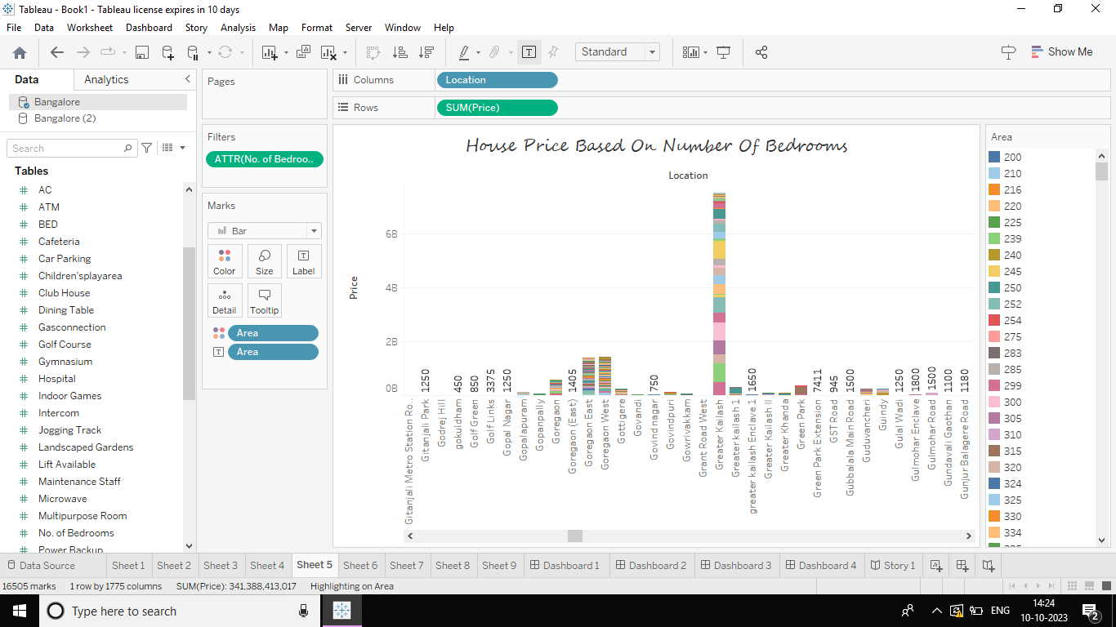

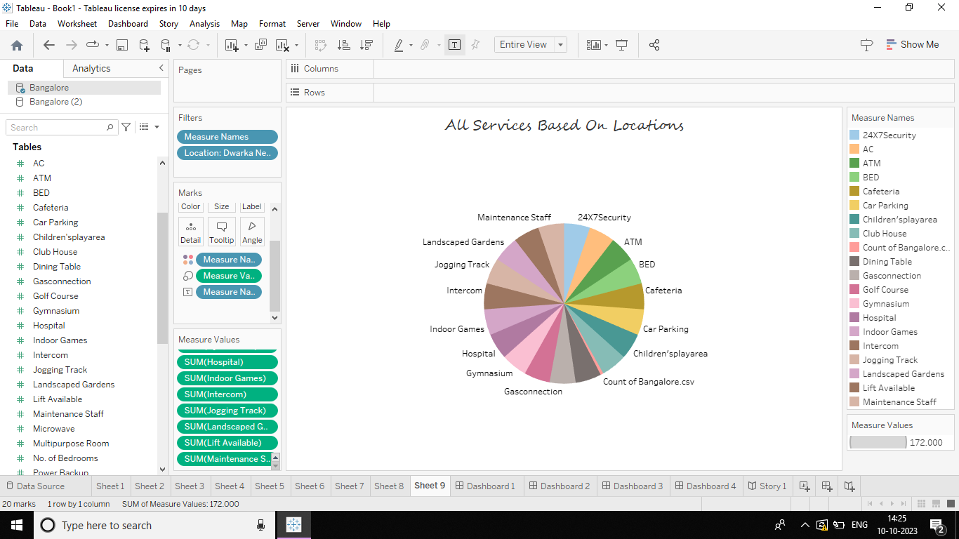

ADVANTAGE

LOWER CONSTRUCTION COSTS COMPARED TO CONVENTIONAL ONE CHECKED FOR A MULTI -YEARS HOUSING SYSTEM.SAFE LIVE ENVIRONMENT IN EXTERME WEATHER CONDIOTIONS FIRE RESISTANCES HIGH THERMAL EFFICIENCY ENERGY SAVINGS.

DISADVANTAGE

PHYSICAL BARRIERS -ESPECIALLY IN CONSTRUCTIONS WITHOUT WINDOWS ,INMANY CASES ,TOO SMALL AMOUNT OF DAY LIGHT,(ROOF,ROOF WITH WOODY VEGETATION)

APPLICATIONS

HOUSE PRICE PREDICTION CAN HELP THE DEVELOPER DETERMINE THE SELLING PRICE OF A HOUSE AND CAN HELP THE CUSTOMER TO ARRANGE THE RIGHT TIME TO PURCHASE A HOUSE

CONCLUSION

BASED ON THE CRITERION OF PRICE CONVERGENCE ,HOUSE PRICES IN THE 15 METEROPOLITIAN CITIES DO NOT CONVERGE TO THE LOOP

FUTURE SCOPE

VARIOUS REPORTS SUGGEST THAT THE PROPERTY MARKET IN INDIA WILL EXHIBIT A COMPOUND ANNUAL GROWTH RATE OF 9.2% DURING THE PERIOD BETWEEN 2023 AND 2028

APPENDIX

ATTACH THE CODE FOR THE SOLUTION BUILT